
Sheffield City Centre Neighbourhood Newsletter
October 2021
Introduction from Inspector Ali Bywater
Welcome to the latest Sheffield City Centre Neighbourhoods Newsletter for October 2021.
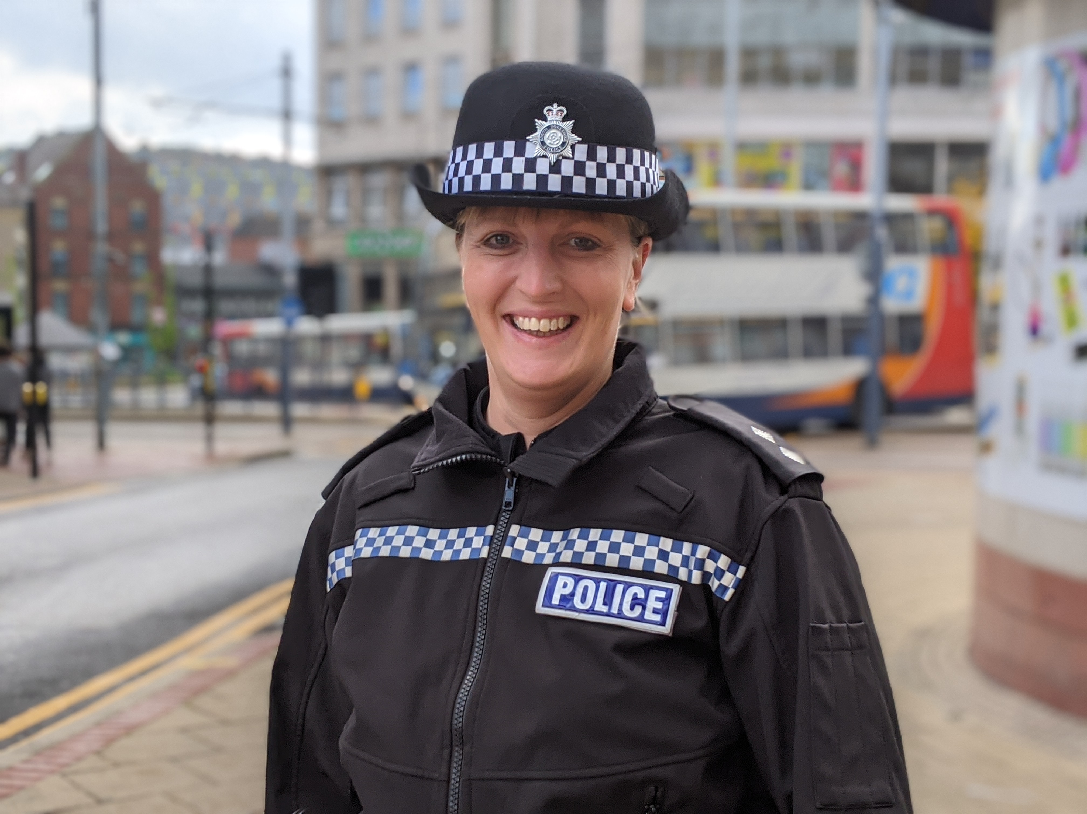
This will be my last newsletter as the City Centre Inspector as I make way for my successor Inspector Danielle Spencer and I move across to the South East Sheffield Neighbourhood Team at the start of November. I will genuinely miss working in the city centre – I have thoroughly enjoyed my time here sine January and am proud of the work that has been undertaken. I am also so glad to see the city centre back fully open again after my first few months being dominated by the pandemic and the challenges that brought for us all.

October has been another busy and challenging month again in Sheffield City Centre, which I will detail more when we get to the main body of the newsletter.

During October, it was Hate Crime Awareness week, and also County Lines Intensification week which saw the Team conduct Operation Sidewinder and do joint work with British Transport Police at the Train Station.

November sees us come into our Dark Nights period, ensuring patrols are in place for anything nuisance related which involves fireworks and other types of Anti-Social Behaviour. These patrols commence this week onwards and will see our Team link in with Youth Services.

Over the coming month of November, we will continue to patrol the city centre, Kelham Island and Highfield to ensure you are kept safe.

Thank you for reading and continuing to support us.

Inspector Ali Bywater

City Centre Neighbourhoods Inspector
Crime and Antisocial Behaviour Update
Partnership Operation – Friday 8 October

Friday 8 October saw the Team join forces with other colleagues from Task Force and the South West Neighbourhood Team, as well as partners from Sheffield City Council’s Community Safety Team, Parking Services, Trading Standards and Immigration. This was for an afternoon and evening of action to tackle crime, ASB and provide a significant visible presence in response to recent concerns around people feeling unsafe in the City Centre. You wouldn’t have believed it was October – it was a lovely sunny warm afternoon – even I managed to escape the confines of my office and get out with the Team.

Drugs dog Roscoe and dog handler Andy joined us as well, with Roscoe’s keen nose working its magic as always! We deployed Operation Sidewinder into key hot spot ASB areas during the daytime economy and then moved on into the night-time economy as licensed premises started to busy up.

Static traffic stop points were used to stop vehicles coming into and going out of the City and Parking Services worked jointly with us to address parking complaints on the Wicker. 40 x vehicles were stopped in total throughout the evening.

The joint multi-agency outreach was also conducted between 1430 and 1630 hours, results detailed later in the newsletter.

Our results were as follows – 27 x stop searches were conducted, 2 x arrests were made for public order offences and breach of bail, 2 x cautions were issued for possession of spice, 3 x cannabis warnings were issued, and 2 x restorative justice disposals were used for possession of cocaine.

The evening of action was well received, targeting ASB and criminality while also proving reassurance.

Some photos are below –

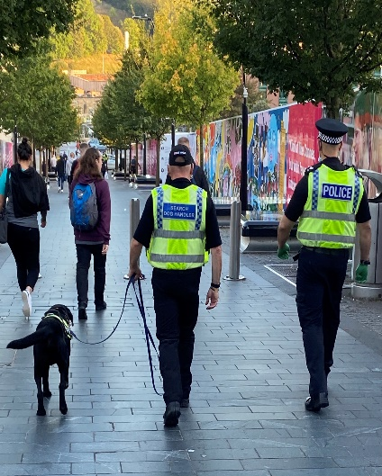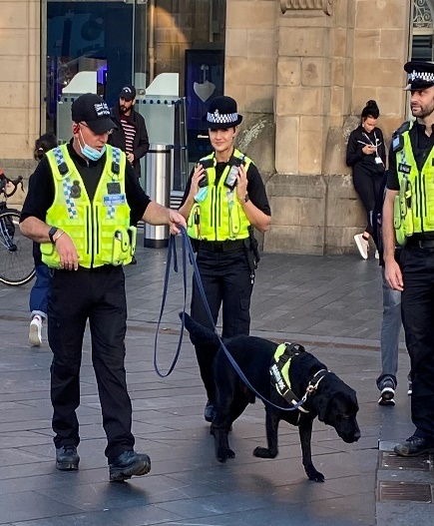

Operation Sidewinder

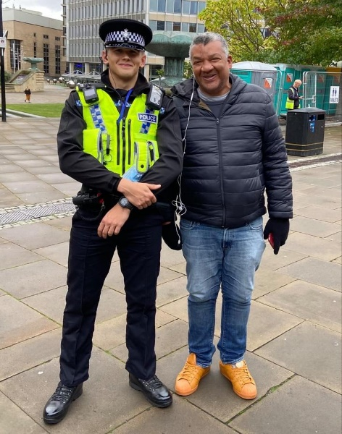
Tuesday 12 October saw the team once again deploy Operation Sidewinder into the daytime economy, in conjunction with tackling County Lines issues. We were joined by PD Roscoe and dog handler Andy and took to the streets on what proved to be a fairly quiet day in town!

Nevertheless, the team had some good results which included 11 x stop searches resulting in 3 x arrests for Possession with Intent to Supply Offences as well as Possession of Offensive Weapons – three males aged 20, 20 and 22 years are now on bail for these offences, 2 x disposals by Restorative Justice for cannabis possession and 1 x person reported on summons for Theft.

The public perception around the day was very positive, as the team were out and about on high visibility patrols, engaging with the community as part of the operation.
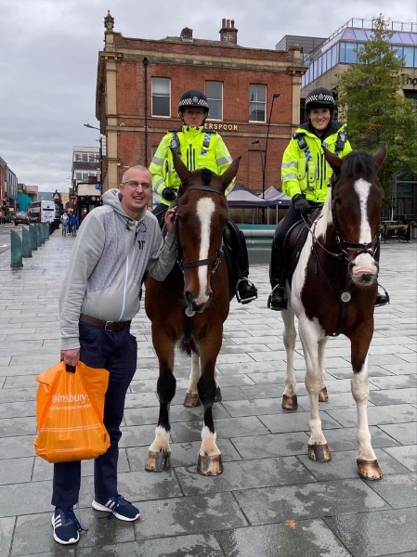
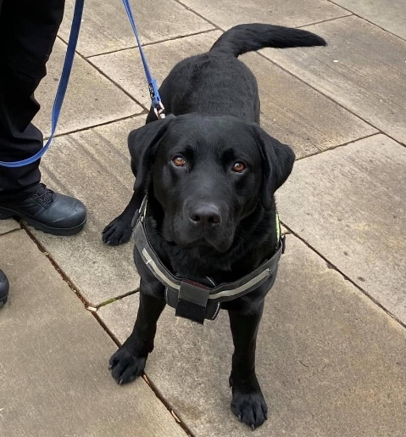

Firearms Discharge – Gell Street

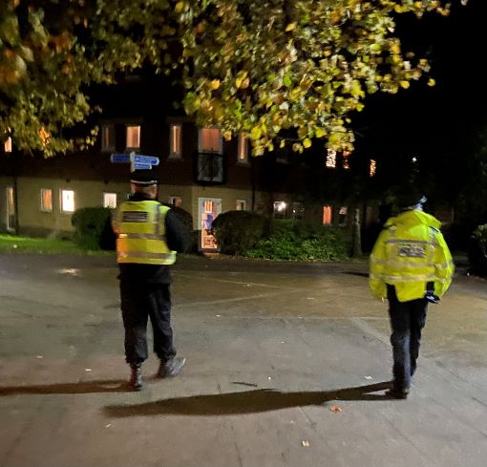
At 9.25pm hours on Wednesday 20 October there were numerous reports from members of the public about gun shots heard in the Gell Street area.

The investigation remains at an early stage and enquiries are continuing at this time to ascertain the full circumstances of what happened by colleagues in the Armed Crime Team. The city centre team has close links to them and have a full reassurance and high visibility patrol plan in place across the weekend which links into the further shooting which occurred in the Exeter Drive area of Broomhall in the early hours of Saturday morning. This is jointly owned by ourselves and the North West Neighbourhood team.


Good Result for robbery offender at Queer Junction

CID colleagues obtained a fantastic result on a 22-year old male Hamza Hussain who was detained for robbery in Queer Junction overnight on Wednesday 6 Octobe.

Through their perseverance and diligent enquiries over the last week, he has now been charged with 2 x Theft offences, 1 x Fraud and 1 x Robbery – he has also been recalled to prison for his efforts!

Spiking Incidents – Update

You will no doubt have seen a heightened media interest this week in spiking incidents and a newly identified Modus Operandi which involves some victims being injected with a needle in order to debilitate them.

To reassure you, there have been no reported cases of this nature in Sheffield but we are now alert to this MO moving forwards.

Our jointly owned plan with CID, Licensing and other partners continues to be implemented around this issue. We have good relationships with our local licensed venues and our licensing teams are in constant contact with their management and staff. We continue to work in partnership with them to ensure that any incidents are reported to us promptly and action is taken. We take all reports of this nature seriously and would urge anyone who has been the victim of drink spiking to report it to us straight away to enable swift action and identity of offenders.

Joint work with Trading Standards – Licensed Premises

On Friday 1 October, PC Oli Wilson, PC Molly Batteson and our Licensing Officer Ian Armitage carried out checks at some of the licensed venues in the City Centre relating to counterfeit alcohol. A number of venues had their spirits checked which was a lengthy but worthwhile process. Only one venue posed any concern which was addressed at the time.

This work links to our ongoing piece of work around the safety of individuals on a night out and in particular substances being placed into alcoholic drinks. Our preventative work around the issue of drink spiking continues. Our focus has been on the student community in the past few weeks, giving consideration to the fact that many students have never enjoyed a night life until now due to the pandemic.

PC Wilson and PC Batteson spent an afternoon at the Gate student accommodation on Eyre Street on Monday this week hosting a stall to raise awareness around spiking and keeping safe on a night out. Their presence was well received by the students they spoke to.

Commercial Burglary Update

The past few weeks has seen a number of commercial burglaries once again which are firmly on our radar. As per previous newsletters, the city centre team have a Problem Oriented Policing (POP) plan around tackling this issue long-term and it remains one of our key priorities.

CID colleagues from the Burglary Team have done some excellent work this month in capturing two City Centre burglars who have both now been charged and remanded with the relative offences.

Gareth Shaw 39 years old was arrested, charged and remanded for a burglary dwelling which occurred in September at a property on Arundel Gate and Amir Kamyar 27 years old was arrested, charged and remanded for two commercial breaks which occurred at vacant student residences on Fenton Street again in September ’21.

Our joint work around tackling commercial burglary continues.
Offenders brought to justice
Results from this month as below –
Amir Hossein Kamyar 30/07/1994 of Goldthorpe, Doncaster – Arrested and Charged with 2 x Commercial Burglaries

Marcin Onysk 02/12/1978 of Furnival Road, Balby, Doncaster – Arrested, Charged and Remanded for Possession of Bladed Articles

Scott Anderson 09/01/1983 of Martin St – Arrested and Charged with Public Order offences and subsequently arrested and charged the following morning after a second incident with Drunk And Disorderly

Jonathan Daley 21/04/1983 of St Peters Close – Arrested and Charged with Criminal Damage

Karl Driver 19/09/1988 of London Rd – Arrested, Charged and Remanded for Breach of Bail

Hamza Hussain 03/09/1999 of Beaconsfield Rd, Rotherham – Arrested, Charged and Remanded for 2 x Theft, 1 x Fraud and 1 x Robbery

William McDonagh 17/03/1979 of No Fixed Abode –Arrested and Charged with 2 x Theft by Shoplifting offences

Sammi Hussain 09/01/1986 of the Wicker – Arrested and Charged with Breach of a Dispersal Order

Gareth Shaw 29/10/1981 of Brightmore Drive – Arrested, Charged and Remanded for Burglary Dwelling and Theft

Josh Hallam 08/10/1998 of Hazelbarrow Crescent – Arrested and Charged with being Drunk and Disorderly in a Public Place

Kieran Parker 13/07/1989 of 30 Collister Gardens – Arrested, Charged and Remanded with Possession of Bladed Article and Breach of suspended sentence

Yafet Zenawi 12/05/2000 of Blonk Street – Arrested and cautioned for 3 x assaults

Corey Lethbridge 28/11/2000 of Myrtle road – Arrested and Charged for common assault. RJ for possess class B

Grenville Cockburn 03/02/1973 of Cobden Street, Derby – Arrested and Charged for disqualified driving, no insurance and fail to provide
Gallery and Comments
Feast of St Francis of Assisi – St Matthews Church

Michaela our Parish Nurse invited our faithful drugs dog Roscoe who I am sure most of you will know by now (he features in our updates monthly and is well loved in the City Centre!) and handler Andy to attend an animal blessing service at St Matthews Church at 6pm on Monday 4th October.
Sergeant Jon Simspon went with Andy and Roscoe and all involved thoroughly enjoyed the service and want to thank Michaela for the invite. Pictures are below –

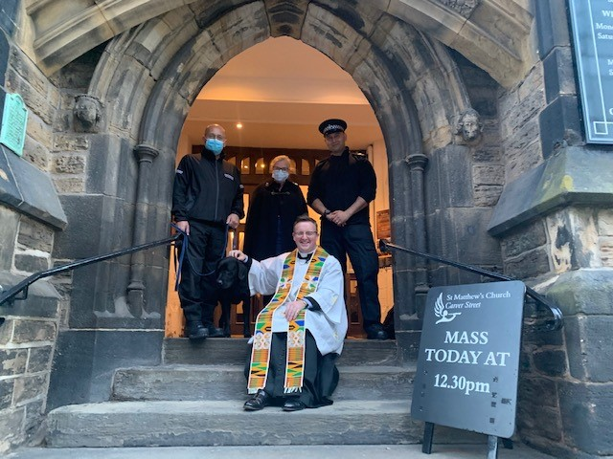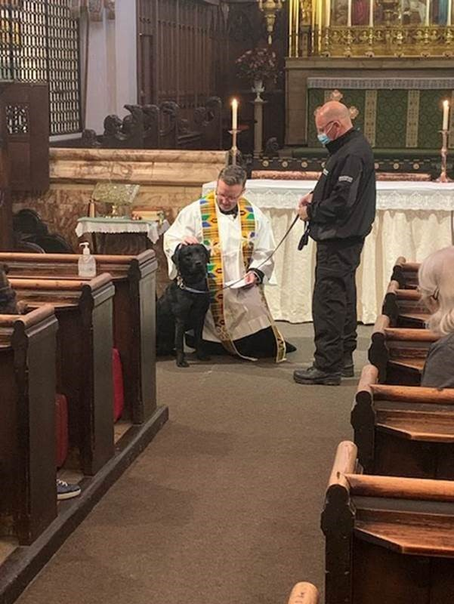

Hate Crime Awareness Week - Engagement Event
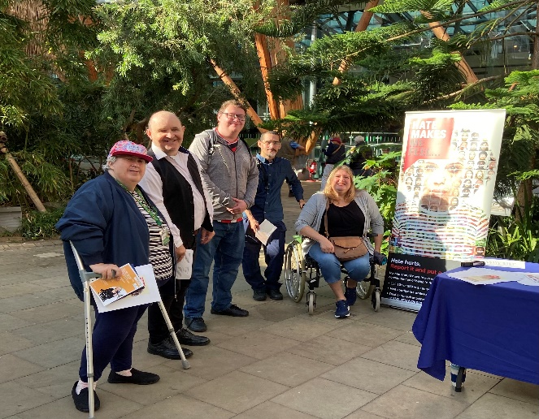

PCSOs Alison and Paul Cundy hosted a Hate Crime Awareness event in the Winter Gardens on Wednesday 13th October. They were joined by volunteers from Sheffield Voices, Disability Sheffield. Everyone seemed to enjoy the event and a lot of people visited to engage and receive advice and support.

25 Years of the Ben’s Centre Celebrations

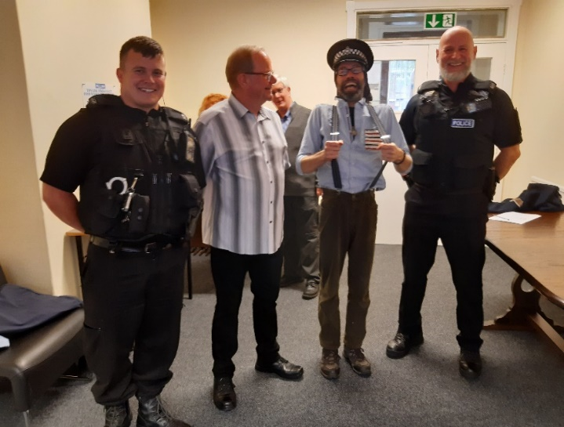
PCs Oli Wilson and Paul Mulcrone attended the Ben’s Centre’s 25th Birthday celebration on Wednesday afternoon.

The Ben’s Centre provides a place of sanctuary for those involved in street culture and substance misuse and was founded in 1996 by ‘Ben’ Sherman who was the Town Hall bobby in his day!

We really appreciated the invite to this celebration – you can see how much fun was had in the picture to the left!

Keeping in touch
Come and see us
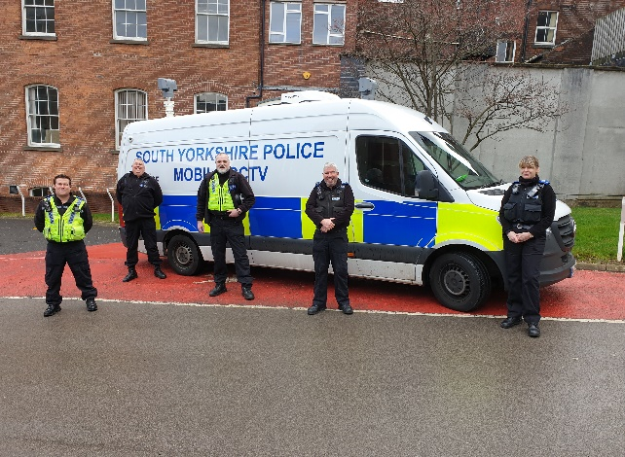
The Team’s PCSOs are able to host Pop Up Police Stations once again now that the pandemic situation has continued to improve.

You can also communicate with us online and we encourage you to do so.

If you see the PCSOs advertise their location on Social Media and are in that area, or if you see them out and about on their daily patrols, please feel free to stop and have a socially distanced chat to them.

We continue to look for new venues to set up our engagement events moving forwards so if anyone has anywhere they would like to see us, or have some space to welcome us, please get in contact with us.

Other ways to keep in touch

- Sign up for SYP Alerts to get messages, updates and information about your area at sypalerts.co.uk
- Like us on Facebook: Sheffield City Centre NHP
- Follow us on Twitter: @Sheffcity_NHP
- Visit southyorks.police.uk for more info or to report non-emergency crime
- Call 101 for non-emergencies or 999 in an emergency
- Call Crimestoppers to give your information anonymously on 0800 555 111


